**GradRooAte User Guide**

**Version 0.0.1**

April 26, 2020

**Group 10 Members**

*Kendal Sutton*

*Joshua Wendl*

*Alec Sears*

*David Leatherwood*

# Table of Contents

**Table of Contents** **2**

**Introduction** **2**

**Quick Start Guide** **4**

**System Requirements** **5**

**Main Scenarios of Use** **6**

Data Entry 6

Schedule 7

**Troubleshooting** **8**

Can’t open project file 8

Conflict 8

# Introduction

The GradRooAte application is designed to assist departments at UMKC to schedule their faculty member’s course classes. This application receives data about the faculty and courses, and detects conflicts in the class schedule based on configurable rules. These rules can enforce that the classes in the schedule are convenient, don’t overlap, and meet the scheduling needs of faculty members.

# Quick Start Guide

|  |
| --- |
| ***Note: .NET Core runtime for desktop is required to run the application.*** *If not installed, you can find it here:* [*https://dotnet.microsoft.com/download/dotnet-core/current/runtime*](https://dotnet.microsoft.com/download/dotnet-core/current/runtime) |

1. Double click the GradRooAte Software icon from the desktop to open program. The startup page for GradRooAte will appear.

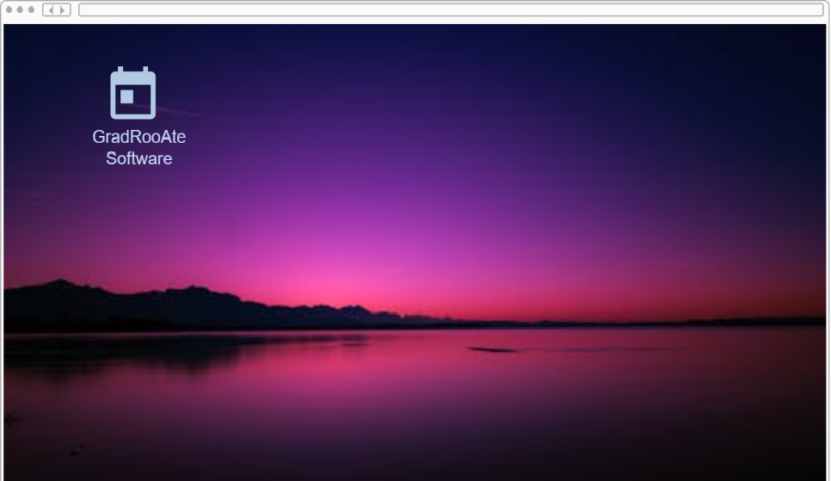

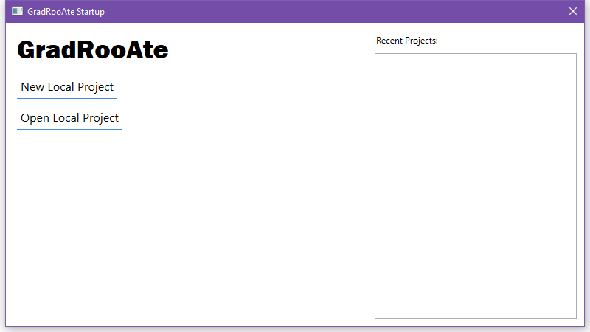  
*Prototype images subject to change*

1. Click New Local Project. Name your project and save it on your local computer.
   1. If you already have a project you want to continue working on, you can select “Open Local Project” and select your project file.
2. The GradRooAte home page will display. The “Data” has icons for faculty, courses, and school. “Schedule” icon to view, edit and delete from the system. “Conflict” will display any errors in scheduling

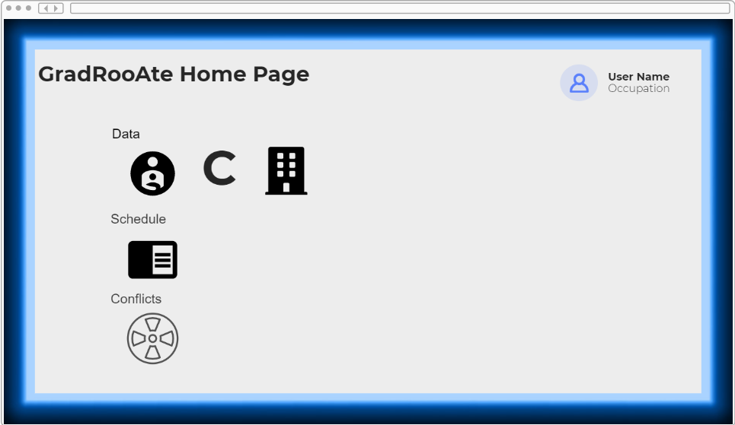  
*Prototype image subject to change*

# System Requirements

The GradRooAte software should be installed on a Windows desktop computer. Refer to the System Documentation for more detailed instructions on installation.

# Main Scenarios of Use

## Data ***Entry***

1. Launch the GradRooAte application, and start a new project or open an existing one.
2. On the main page, under the Data category, there are options to view, edit, and add information for faculty, courses, or rooms.

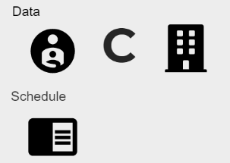  
*Prototype image subject to change*

1. The Faculty icon will display the following.

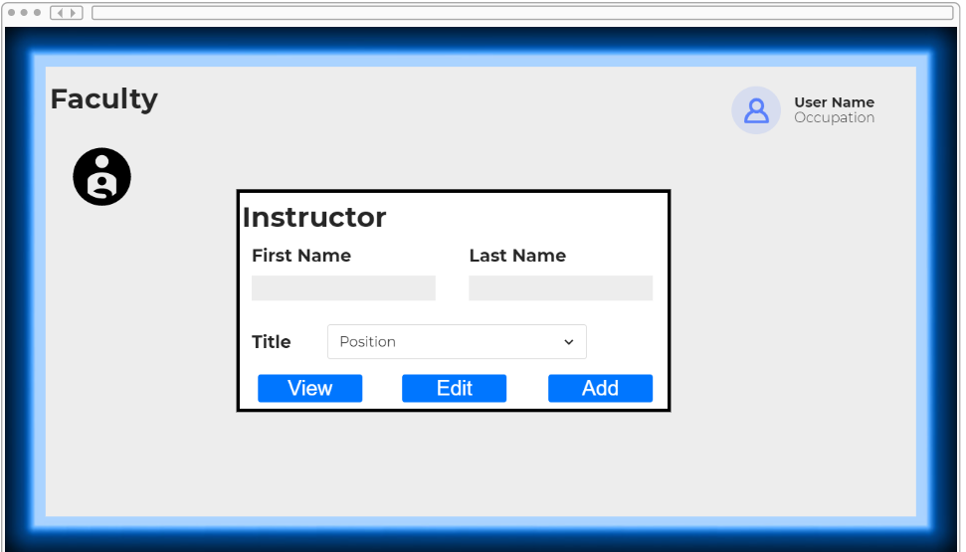  
*Prototype image subject to change*

## Schedule

1. Launch the GradRooAte application, and start a new project or open an existing one.
2. Tap the schedule icon on the main page.

  
*Prototype image subject to change*

1. Scheduling window will be displayed.

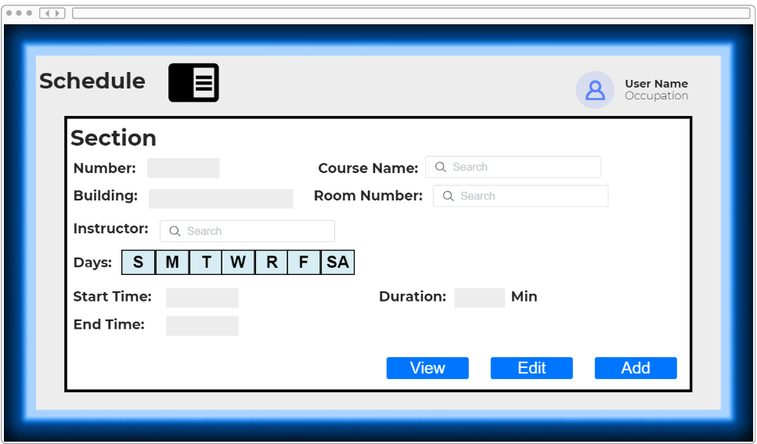  
*Prototype image subject to change*

# Troubleshooting

## Can’t open project file

If the application reports that it can’t open a project file, it may not be a GradRooAte project file. Check that the file you’re trying to open is a .grdb file. If the application can’t open a .grdb file, it may be due to the file being corrupted or an error in the application.

## Conflict

If there are any problems with scheduling an instructor, the Conflict icon on the home page will display any issues that have occured.

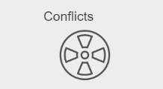  
*Prototype image subject to change*